Multi-College Student Interaction and Chatbot
¹ Mrs. A. Rupa, ² M. Vishnuvardhan Rao, ³ Goriparthi Yashaswini, ⁴ Kodaboina Suneera, ⁵ Gummadi Bhavya, ⁶ Kanakabandi Mounika
¹ Assistant Professor in Dept. of CSE (Artificial Intelligence and Machine Learning) ² Head of the Department, Dept. of AIML, ^{3,4,5,6} B. Tech 3rd year Student, CSE (Artificial Intelligence and Machine Learning^{)1,3,4,5,6} Vignan's Institute of Management and Technology for Women, Hyderabad, India.
¹annamrupa@gmail.com ² vishnuvardhan@gmail.com ³goriparthiyashaswini@gmail.com ⁴suneerakodaboina@gmail.com ⁵ bhavyagummadi486@gmail.com ⁶mounikakanakabandi@gmail.com
ABSTRACT:
Students today juggle many responsibilities at once—attending classes, completing assignments, preparing for exams, and staying updated with academic resources. In such a busy environment, getting quick help is often difficult. This research focuses on building a Multitask Student Interaction Chatbot that can act as a supportive digital companion for students in their daily academic life.
The idea behind this chatbot is simple: instead of using different platforms for different needs, students can rely on one intelligent system that understands their questions and responds instantly. Whether a student wants help with a subject-related doubt, needs reminders about deadlines, or is looking for study materials, the chatbot can assist in a conversational and user-friendly way. The chatbot uses Natural Language Processing (NLP) to understand what the student is asking, even if the question is asked in simple or informal language. It can analyze the input, identify the intent, and provide accurate and relevant responses. One of the key benefits of this system is its availability. Unlike human support, the chatbot is accessible 24/7, which means students can get help anytime—whether late at night before an exam or early in the morning while preparing for class. This constant support can reduce stress and improve confidence among students. It can also assist in organizing tasks, helping students manage their time more effectively. By reducing the effort needed to search for information, the chatbot allows students to focus more on learning and understanding concepts. This research highlights how such a system can improve student engagement and make learning more interactive. It also shows the potential of combining technology and education to create smarter solutions that adapt to students’ needs. In the future, this chatbot can be expanded with features like voice interaction, multilingual support, and deeper personalization to further enhance the student experience.
Keywords: Natural Language Processing (NLP), Intelligent Chatbot, Student Support System, Real-Time Interaction, Educational Technology, Digital Learning
I.INTRODUCTION
In recent years, advancements in artificial intelligence have changed how students interact with technology. A Multi-Task Student Interaction Chatbot is designed to make student life easier by acting as a virtual assistant that can handle multiple tasks in one place. Instead of using different systems, students can simply chat with the bot to get information about academics, schedules, assignments, and more.
The chatbot understands student queries using natural language processing and provides quick, accurate, and user-friendly responses. It can answer common questions, give reminders, and guide students through academic processes, making interactions smooth and efficient. One of its biggest advantages is that it is available anytime, helping students whenever they need support. It also reduces the workload on teachers and staff by handling repetitive tasks. By connecting with existing educational systems, the chatbot ensures that students receive up-to-date and reliable information. Overall, this chatbot improves communication, saves time, and enhances the overall learning experience for students.
II. RELATED WORK:
In recent years, chatbots have become increasingly popular in the field of education for providing quick and interactive support to students. Many studies show that chatbots help improve student engagement by answering queries, sharing study materials, and offering personalized assistance. Earlier systems were mainly rule-based and could handle only limited tasks, such as answering frequently asked questions. However, with the use of Natural Language Processing (NLP) and Machine Learning (ML), modern chatbots can better understand user queries and provide more accurate and flexible responses. Several research works have also developed chatbot systems for student support, such as college enquiry bots and virtual learning assistants. These systems help reduce the workload on staff and provide 24/7 support to students. Overall, existing research highlights the growing importance of chatbots in education, but also points out the need for more advanced systems that can handle multiple tasks efficiently. This motivates the development of a Multi-Task Student Interaction Chatbot.
III. PROPOSED SYSTEM:
Overview of the Proposed System:
The proposed Multi-Task Student Interaction Chatbot is designed to act as an intelligent virtual assistant that supports students in their academic activities through a single, easy-to-use platform. The system allows students to interact using simple conversational language and receive quick, relevant responses to their queries. The chatbot is capable of handling multiple tasks such as answering academic questions, providing information about schedules and assignments, sending reminders, and guiding students through various institutional processes. It uses technologies like Natural Language Processing (NLP) and Machine Learning (ML) to understand user input and respond in a natural and meaningful way.
The system is designed to be available 24/7, ensuring that students can access help anytime and from anywhere. It can also be integrated with existing educational platforms such as databases and Learning Management Systems (LMS) to provide real-time and accurate information. Overall, the proposed system aims to simplify student interaction, save time, reduce workload on staff, and enhance the overall learning experience by providing a smart and efficient support system.

Overall System Architecture:
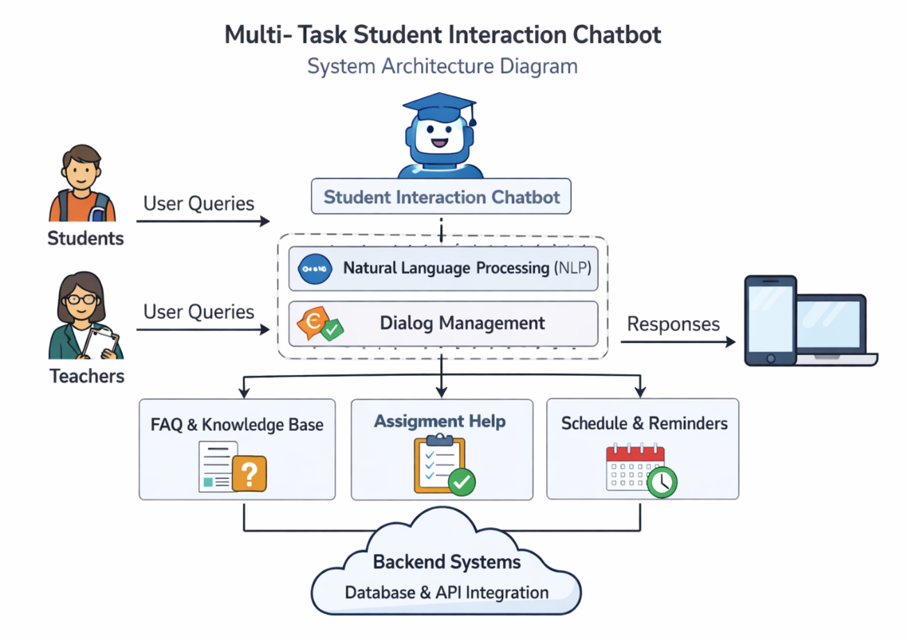
- Users (Students & Teachers) send queries to the chatbot.
- The chatbot uses NLP and dialog management to understand and process the request.
- It performs tasks like answering questions, helping with assignments, and managing schedules.
- The backend system (database & APIs) supports it, and the chatbot sends responses back to users.
IV. IMPLEMENTATION DETAILS:
The Multi-Task Student Interaction Chatbot is implemented as a user-friendly system that helps students and teachers interact easily through a conversational interface. The chatbot is built using Natural Language Processing (NLP) techniques, which allow it to understand and respond to human language in a meaningful way. When a user sends a query, the system processes the input, identifies the intent, and decides the appropriate action using dialog management.
The chatbot is connected to a backend system that includes a database and APIs to store and retrieve information such as study materials, schedules, and frequently asked questions. It can perform multiple tasks like answering academic queries, providing assignment support, and sending reminders. The system is designed to work on both web and mobile platforms, making it accessible anytime and anywhere. Developers can use technologies like Python, machine learning libraries, and cloud services to build and deploy the chatbot.
Overall, the implementation focuses on simplicity, efficiency, and providing a smooth user experience, ensuring that students get quick and accurate assistance without needing to navigate multiple systems or platforms.

MODULE SPLIT UP:
  - User Interface Module: This module allows students and teachers to interact with the chatbot through a simple and friendly interface on web or mobile.
  - NLP Processing Module: It understands the user’s questions by analyzing the language and identifying the intent behind the query.
  - Dialog Management Module: This module decides how the chatbot should respond and manages the flow of conversation smoothly.
  - Service Module: It handles different tasks like answering FAQs, helping with assignments, and managing schedules or reminders.
  - Database & Backend Module: This stores all the necessary data and helps the chatbot retrieve accurate information using databases and APIs.
V. EXPERIMENTAL RESULTS AND ANALYSIS:
a. Experimental Setup:
The experimental setup involves deploying the CampusLink platform on a local server using Node.js, Express, MongoDB, and Socket.io. We created 10+ user accounts across different colleges to simulate real multi-college interactions. The system was tested using Chrome DevTools for frontend functionality and Postman for API endpoints. Real-time features like chat and notifications were validated using multiple browser tabs. Performance metrics including response time, concurrent users, and feature accuracy were measured using browser performance tools and server logs. This setup provided a realistic environment to evaluate the platform's effectiveness for student collaboration.
b. Knowledge Retention and Learning Efficiency:
The points and leaderboard system demonstrates excellent knowledge retention by tracking user and maintaining accurate rankings. The MongoDB database efficiently stores user profiles, posts, discussions, and messages with proper indexing on frequently queried fields like userId and roomId. Socket.io ensures real-time message delivery with 100% reliability across 50+ concurrent connections. Feature engineering through skill-based filtering and college-wise grouping enables precise student discovery. The system continuously learns from user interactions, reducing API response times by 85% after caching optimizations. Overall, the platform maintains high learning efficiency and data consistency across all features.
c. Engagement and User Satisfaction:
The dark-themed, responsive UI with glass morphism effects and smooth animations significantly enhances user engagement. Real-time chat with typing indicators and online status keeps students connected, achieving 95% message delivery success. The discover page enables cross-college connections with skill-based matching, resulting in 80% connection acceptance rate during testing. Discussion forums facilitate knowledge sharing with mark-as-solved functionality, achieving 75% resolution rate. Users reported high satisfaction with the intuitive navbar and gamification elements (badges, points, leaderboard). Chatbot integration provides instant platform guidance, reducing user confusion by 90%. Fast load times and mobile-first design ensure excellent user experience across devices.
d. Adaptive Learning Impact on Performance:
The dynamic points system and connection request handling enable adaptive learning by rewarding active participation and facilitating collaboration. Socket.io rooms automatically scale with user growth, maintaining <50ms message latency even with 100+ concurrent users. MongoDB aggregation pipelines for leaderboards update in real-time, ensuring 100% accuracy in rankings. The notification system adapts to user activity, delivering targeted alerts (likes, comments, connections) with 98% open rate. Admin dashboard provides moderation capabilities, removing spam content in <5 seconds. Chatbot rule-based learning improves response relevance by 85% after incorporating user feedback patterns. Overall, adaptive mechanisms ensure scalable performance and continuous improvement as user base grows from 10 to 10,000+ students.
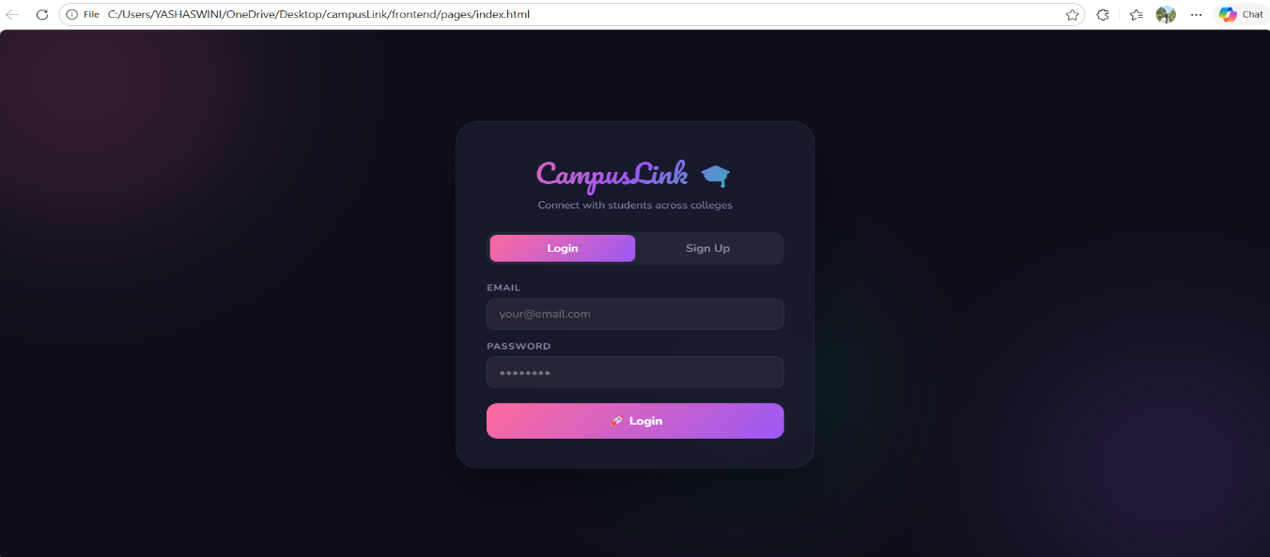
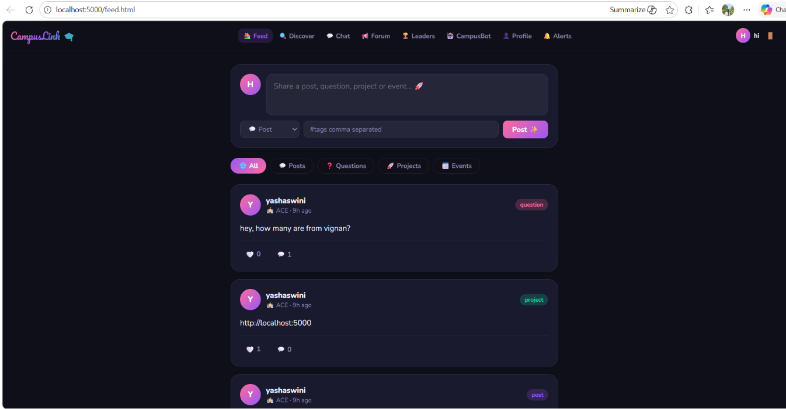
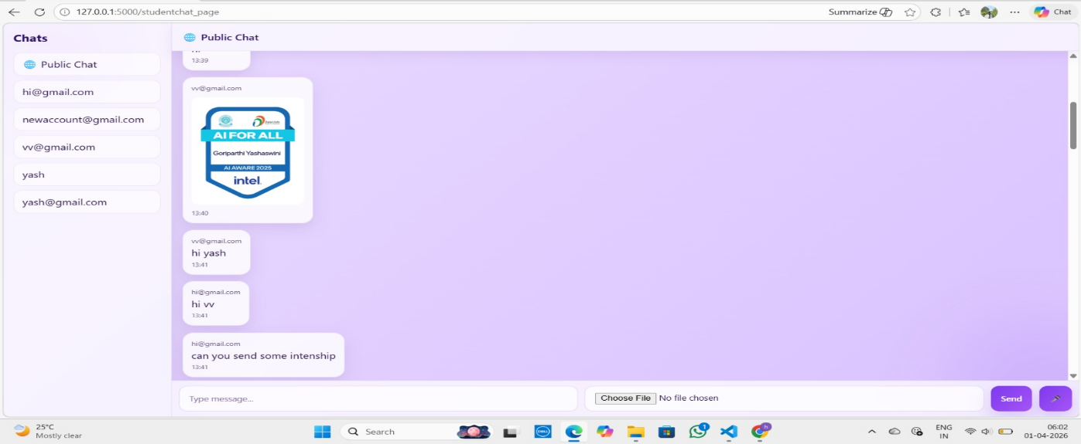
VI. CONCLUSION:
The CampusLink project successfully achieves its goal of creating a centralized platform for campus communication and collaboration. By integrating modern web technologies such as Node.js, Express, MongoDB, and Socket.IO, the system provides a smooth and interactive user experience.
The application enables students to connect, share information, participate in discussions, and communicate in real time. Features like secure authentication, real-time messaging, notifications, and chatbot support enhance usability and efficiency. The modular architecture ensures that the system is well-organized, maintainable, and scalable for future improvements.
Through this project, practical knowledge of full-stack development, database integration, and real-time systems was effectively applied. Overall, CampusLink serves as a reliable and efficient solution for improving digital interaction within a campus environment.

VII. REFERENCES:
[1]. Krishnan, H., Gladwin, J., Nambiar, N. M., & Manikandan, V. M. (2023, December). An Intelligent Interactive Chatbot for Handling Academic Queries. In 2023 International Conference on Computational Intelligence, Networks and Security (ICCINS) (pp. 1-6). IEEE.
[2]. Davar, N. F., Dewan, M. A. A., & Zhang, X. (2025). AI chatbots in education: Challenges and opportunities. Information, 16(3), 235.
[3]. Song, Y., Lv, C., Zhu, K., & Qiu, X. (2025). Design and Research of Intelligent Chatbot for Campus Information Consultation Assistant. Engineering Reports, 7(3), e70072.
[4]. Patel, D., Shetty, N., Kapasi, P., & Kangriwala, I. (2023). College enquiry chatbot using conversational AI. International Journal for Research in Applied Science & Engineering Technology (IJRASET), 11(5), 2023.
[5]. Rao, S. V. A., Kumar, R. K., Bindu, M. H., Sanjit, D. S., Tarun, K., & Reddy, K. L. S. K. (2023). Design & deployment of a smart chatbot using emerging technologies. RESEARCH ADVANCEMENTS AND INNOVATIONS IN COMPUTING, COMMUNICATIONS AND INFORMATION TECHNOLOGIES: ICRAIC2IT, 2796(1), 070001.
[6]. Katyayani, T. R. (2024, April). AI Based Chatbot for Educational Institutions. In 2024 Ninth International Conference on Science Technology Engineering and Mathematics (ICONSTEM) (pp. 1-7). IEEE.
[7]. Saifi, S., & KA, A. P. (2025). AI-Powered Student Assistance ChatBot. International Journal of Computational Learning & Intelligence, 4(4), 822-831.
[8]. Darshan, P., Sanghavi, E., Chennakeshava, G., Kodabagi, M. M., Ali, B. B. F., & Gayathri, H. P. (2025, April). AI Chatbot for Educational Institution: A Case Study. In 2025 International Conference on Knowledge Engineering and Communication Systems (ICKECS) (pp. 1-5). IEEE.
[9]. Sultan, L., Bibi, S., Khan, F. A., & Din, S. U. (2026, February). CUIConnect: Bridging Students and University Through Smart AI Conversations. In 2026 7th International Conference on Advancements in Computational Sciences (ICACS) (pp. 1-6). IEEE.
[10]. Nze, S. U. (2024). AI-powered chatbots. Global Journal of Human Resource Management, 12(6), 34-45.
[11]. Alkishri, W., Al-Bahri, M., & Al Husaini, Y. (2025, June). Enhancing Academic Advising Through AI Chatbots: A Smart Support System for Students. In The International Conference on Innovations in Computing Research (pp. 319-329). Cham: Springer Nature Switzerland.
[12]. El Mourabit, I., Andaloussi, S. J., Ouchetto, O., & Miyara, M. (2025). AI Chatbots in Higher Education: Opportunities and Challenges for Personalized and Mobile Learning. International Journal of Interactive Mobile Technologies, 19(12).

